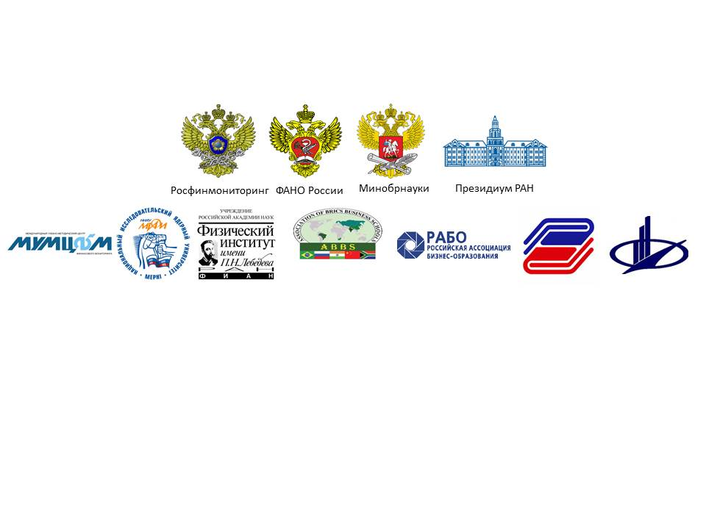

**AGENDA**

**III**

**III Network AML/CFT Institute International Scientific and Research Conference**

**“FinTech and RegTech: Possibilities, Threats and Risks of Financial Technologies”**

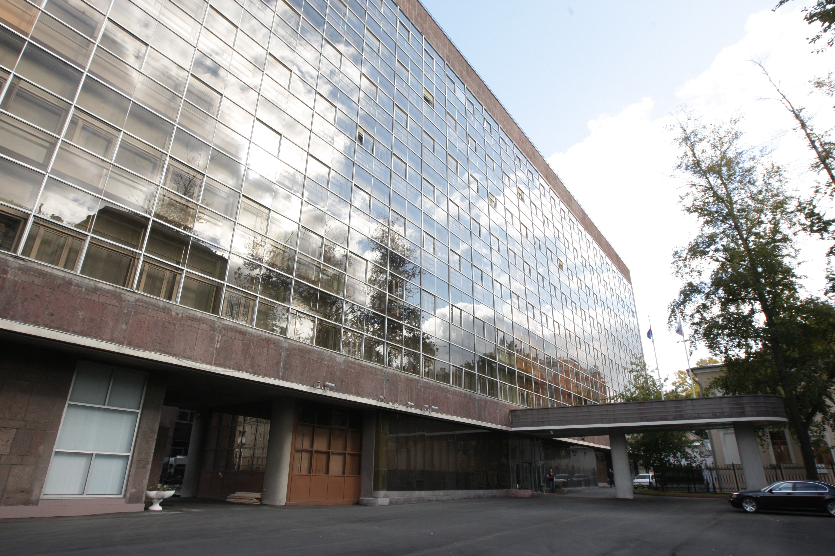

**Russian Federation, Moscow**

**November 21-23, 2017**

*Dear participants of the Forum*

***“FinTech and RegTech: Possibilities, Threats and Risks of Financial Technologies”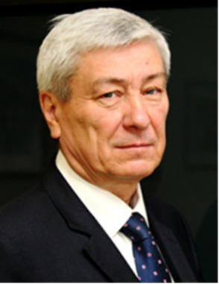****,*

*On behalf of the Federal Financial Monitoring Service,*

*I welcome you in the Russian capital!*

*Current global trends are directly connected with the revolutionary technologies in the financial sector, including payment systems, asset management, credit, insurance and foreign exchange transactions.*

*New challenges and threats emerge. They have a supranational character and may not be tied to specific jurisdictions, therefore they are not fully regulated by the national legislation. Such phenomena can include growing popularity of cryptocurrency, crowdfunding technology (inter alia, via non-traditional means of payment), use of biometric technology during identification procedures for the execution of payment transactions.*

*During the last revision of the Financial Action Task Force (FATF) standards, the special focus was on assessing risks of money laundering or terrorist financing that could arise due to the development of new products and business practices, including the use of modern technology.*

*One of international, regional and national AML/CFT systems’ priorities in terms of prospects for the introduction of new financial technology (FinTech) is the creation of a platform for constructive dialogue and support of innovation in financial services, and finding solutions for their regulation and control.*

*FinTech innovations can improve financial inclusion of customers, entities and communities. The financial services paradigm can be reorganized around new platforms, infrastructures and relations with service providers. The prospect of the international AML/CFT community’s efforts is to understand how these changes will affect the landscape of financial services, stability of the financial system, opportunities to identify, eliminate or reduce risks and threats.*

*In the modern world financial threats and risks became quite a systemic thing. Therefore, they can be dealt with only by systemic methods. Scientific and educational organizations play an important role in this fight. Joint efforts of financial monitoring bodies, academic community and network AML/CFT Institute will contribute to strengthening and development of the system of international and regional financial security.*

*Yours sincerely,*

*Yury Chikhanchin*

*Rosfinmonitoring Director*

**Conference Program Committee**

**Committee Chairman** – **Yury Chikhanchin**, Director of the Federal Financial Monitoring Service, Chairman of the network AML/CFT Institute Council

**Committee Co-Chairs:**

1. **Olga Vasilyeva,** Minister of Education and Science of the Russian Federation
2. **Mikhail Kotyukov**, Head of the Federal Agency for Scientific Organizations of the Russian Federation
3. **Alexander Sergeyev,** President of the Russian Academy of Sciences

**Members of the Conference Program Committee:**

1. **Sergey Ablameyko,** Rector of the Belarus State University, member of the network AML/CFT Institute Council
2. **Chinara Adamkulova,** Rector of the Kyrgyz National University named after Jusup Balasagyn, member of the network AML/CFT Institute Council
3. **Adam Albekov**, Rector of the Rostov State University of Economics, member of the network AML/CFT Institute Council
4. **Bahodir Begalov,** Rector of the Tashkent Financial Institute, member of the network AML/CFT Institute Council
5. **Chingiz Bekenov,** Director of the Training and Methodology Centre at the State Financial Intelligence Agency under the government of the Kyrgyz Republic, member of the network AML/CFT Institute Council
6. **Mahmujon Boltabayev,** Rector of the TashkentStateEconomic University, member of the network AML/CFT Institute Council
7. **Yevgeny Vaganov,** Rector of the Siberian Federal University, member of the network AML/CFT Institute Council
8. **Erkin Gadoyev,** Rector of the Tax Academy at the State Tax Committee of the Republic of Uzbekistan, member of the network AML/CFT Institute Council
9. **Viktor Grishin,** Rector of the Plekhanov Russian University of Economics, member of the network AML/CFT Institute Council
10. **Fyodor Voytolovsky,** Deputy Director of the Institute of World Economy and International Relations of the Russian Academy of Sciences, RAS Academician
11. **Alexey Zabelin**, Rector of the Moscow University of Finance and Law, member of the network AML/CFT Institute Council
12. **Sergei Ivanchenko**, Rector of the Pacific National University, member of the network AML/CFT Institute Council
13. **Yesemurat Kamyazov,** Rector of the Tashkent State University of Law, member of the network AML/CFT Institute Council
14. **Victor Koksharov,** Rector of the Ural Federal University named after the first President of Russia B. N. Yeltsin, member of the network AML/CFT Institute Council
15. **Natalya Korjova,** President of the Financial Academy under the Ministry of Finance of the Republic of Kazakhstan, member of the network AML/CFT Institute Council
16. **Nikolai Kolachevsky,** Director of P.N.Lebedev Federal State Budgetary Scientific Institution of the Russian Academy of Sciences, RAS Academician
17. **Yerkin Kubeev**, Rector of the E. A. Buketov Karaganda State University, member of the network AML/CFT Institute Council
18. **Kambar Kudrat,** Rector of Financial and Economic Institute of Tajikistan, member of the network AML/CFT Institute Council
19. **Oleg Kuznetsov**, President of the Russian Academy of Natural Sciences, member of the network AML/CFT Institute Council
20. **Ivan Lobanov,** Rector of the State University of Management, member of the network AML/CFT Institute Council
21. **Valery Makarov**, Director of the Central Economics and Mathematics Institute of the Russian Academy of Sciences, academician of the Russian Academy of Sciences
22. **Almaz Nasyrov**, Rector of the Public Administration Academy under the President of the Kyrgyz Republic, member of the network AML/CFT Institute Council
23. **Vladimir Nechaev,** Acting Rector of the Sevastopol State University, member of the network AML/CFT Institute Council
24. **Vladimir Nifadyev**, Rector of the Kyrgyz-Russian Slavic University named after the first President of the Russian Federation B. N. Yeltsin, member of the network AML/CFT Institute Council
25. **Alexander Novikov**, Rector of the Novosibirsk State University of Economics and Management, member of the network AML/CFT Institute Council
26. **Gennady Osipov**, Director of the Institute of Social and Political Studies of the Russian Academy of Sciences, academician of the Russian Academy of Sciences
27. **Andrey Rudskoy**, Rector of Peter the Great St. Petersburg Polytechnic University, corresponding member of the Russian Academy of Sciences, member of the network AML/CFT Institute Council
28. **Nurali Salikhov,** Rector of theRussian-Tajik (Slavonic) University,member of the network AML/CFT Institute Council
29. **Tulkin Teshabaev,** Rector of the Tashkent University of Information Technology, member of the network AML/CFT Institute Council
30. **Andrey Falaleev,** Acting Rector of the Vernadsky Crimean Federal University, member of the network AML/CFT Institute Council
31. **Taliya Khabrieva**, Director of the Institute of Legislation and Comparative Law under the Government of the Russian Federation, Vice-President of the Russian Academy of Sciences, academician of the Russian Academy of Sciences, member of the network AML/CFT Institute Council
32. **Chitilencheri Ravindranathan**, honorary professor and Council member of the Xavier Institute of Management and Entrepreneurship (XIME), member of the Association of BRICS Business Schools Council, Bangalore, India(to be confirmed)
33. **Yevgeny Chuprunov**, Rector of the Lobachevsky State University of Nizhny Novgorod, member of the network AML/CFT Institute Council
34. **Shimov Vladimir,** Rector of the Belarus State Economic University, member of the network AML/CFT Institute Council
35. **Mikhail Eskindarov**, Rector of the Financial University under the Government of the Russian Federation, member of the network AML/CFT Institute Council

**Conference Steering Committee**

**Chairman of the Steering Committee** – **Vladimir Glotov**, Deputy Director of the Federal Financial Monitoring Services, Director of the Institute of Financial and Economic Security at the National Research Nuclear University (NRNU MEPhI), Deputy Chairman of the network AML/CFT Institute Council

**Co-chairs of the Steering Committee:**

1. **Pavel Zenkovich,** State Secretary, Deputy Minister of Education and Science– Co-Chair of the IWG
2. **Nikolai Kolachevsky,** Director of P.N.Lebedev Federal State Budgetary Scientific Institution of the Russian Academy of Sciences, RAS Academician
3. **Ivan Lobanov,** Rector of the State University of Management, member of the network AML/CFT Institute Council
4. **Yevgeny Bazhanov**, Rector of the Diplomatic Academy of Russian Foreign Ministry, member of the network AML/CFT Institute Council
5. **Mikhail Strikhanov,** Rector of the National Research Nuclear University (MEPhI), Deputy Chairman of the network AML/CFT Institute Council
6. **Alexey Zabelin**, Rector of the Moscow University of Finance and Law, member of the network AML/CFT Institute Council

**Members of the Steering Committee:**

1. **Vladimir Godin,** Head ofInformation Systems Department, State University of Management, Professor, PhD in Economics
2. **Vladimir Ovchinnikov**, Deputy General Director, International Training and Methodology Centre for Financial Monitoring (ITMCFM) , Director of the network AML/CFT Institute
3. **Oleg Ivanov,** Deputy Development Director,P.N. Lebedev Federal State Budgetary Scientific Institution of the Russian Academy of Sciences
4. **Andrey Leonidov,** Head of Mathematical Complex Systems Modeling Laboratory, Department of Theoretical Physics, P.N. Lebedev Federal State Budgetary Scientific Institution of the Russian Academy of Sciences, PhD in Physics and Mathematics
5. **Anna Norkina**, Deputy Director of the Institute of Financial and Economic Security, NRNU MEPhI, PhD in Economics
6. **Tatyana Zakuratseva,** First Vice Rector of the Diplomatic Academy of Russian Foreign Ministry, Deputy Chair
7. **Oleg Ivanov**, General Director of the International Training and Methodology Center for Financial Monitoring (ITMCFM)
8. **Ekaterina Butkeeva**, Deputy Head of Education and Science Department, ITMCFM, PhD in Pedagogical science
9. **Irina Ivanova**, Advisor to the Director, Federal Financial Monitoring Service
10. **Elena Bochkareva**, Director, Institute of Additional Education, Moscow University of Finance and Law, PhD in Economics
11. **Pavel Kukushkin**, Deputy Head of International Department , ITMCFM
12. **Shamil Magomedov,** Head of the AML/CFT Laboratory, Market Economy Institute of the Russian Academy of Sciences, Professor, PhD in Economics
13. **Alexey Petrenko**, Head of the International Cooperation Department, Federal Financial Monitoring Service
14. **Giorgy Ramishvili**, Head of International Department, ITMCFM
15. **Nina Smirnova,** Deputy Head of International Department, ITMCFM
16. **Irina Shilina**, Head of Education and Science Department, ITMCFM

**Conference Participants**

1. Federal Financial Monitoring Service (Headquarters and Interregional Departments)
2. Federal Agency for Scientific Organizations of the Russian Federation
3. Russian Academy of Sciences
4. Russian Association of Business Education
5. Eurasian Group on Combating Money Laundering and Financing of Terrorism (EAG) Secretariat
6. Commonwealth of Independent States (CIS) Executive Committee
7. Public Administration Academy under the President of the Kyrgyz Republic (Kyrgyzstan)
8. Belarus State University (Belarus)
9. Belarus State Economic University (Belarus)
10. Higher School of Economics (Russia)
11. State University of Management (Russia)
12. Diplomatic Academy of Russian Foreign Ministry (Russia)
13. Institute of Legislation and Comparative Law under the Government of the Russian Federation (Russia)
14. Primakov National Research Institute of World Economy and International Relations (Russia)
15. Institute of Social and Political Studies of the Russian Academy of Sciences (Russia)
16. Institute of Security and Information Analysis (Russia)
17. E. A. Buketov Karaganda State University (Kazakhstan)
18. China Centre for Anti-money Laundering Studies, Fudan University, Shanghai (China)
19. Vernadsky Crimean Federal University (Russia)
20. Kyrgyz National University named after Jusup Balasagyn (Kyrgyzstan)
21. Kyrgyz-Russian Slavic University named after the first President of Russia B N. Yeltsin (Kyrgyzstan)
22. International Training and Methodology Center for Financial Monitoring (ITMCFM) (Russia)
23. Moscow University of Finance and Law (Russia)
24. Tax Academy at the State Tax Committee of the Republic of Uzbekistan (Uzbekistan)
25. National Research Nuclear University MEPhI (Russia)
26. Lobachevsky State University of Nizhny Novgorod (Russia)
27. Novosibirsk State University of Economics and Management "NSUEM" (Russia)
28. Beijing University, International Research Centre on Anti-Money Laundering, Terrorism Financing and Tax Evasion, Faculty of Law (China)
29. Beijing Foreign Studies University (China)
30. Rostov State University of Economics (RSUE) (Russia)
31. Russian Academy of Natural Sciences (Russia)
32. Plekhanov Russian University of Economics (Russia)
33. Russian-Tajik (Slavonic) University (Tajikistan)
34. Peter the Great St. Petersburg Polytechnic University (Russia)
35. Sevastopol State University (Russia)
36. Siberian Federal University (Russia)
37. Tashkent State Economic University (Uzbekistan)
38. Tashkent State University of Law (Uzbekistan)
39. Tashkent University of Information Technology (Uzbekistan)
40. Tashkent Financial Institute (Uzbekistan)
41. Pacific National University (Russia)
42. Ural Federal University named after the first President of Russia B N. Yeltsin (Russia)
43. Training and Methodology Centre at the State Financial Intelligence Agency under the government of the Kyrgyz Republic (Kyrgyzstan)
44. Financial University under the Government of the Russian Federation (Russia)
45. Financial and Economic Institute of Tajikistan (Tajikistan)
46. Central Economic Mathematical Institute of the Russian Academy of Sciences (Russia)
47. Jilin University of Finance and Economics (China)
48. Karunya University (India)
49. P.N. Lebedev Physical Institute of the Russian Academy of Sciences (Russia)

**Day 1: Tuesday, November 21, 2017**

**Venue -** P.N. Lebedev Physical Institute of the Russian Academy of Sciences (Russia)

**Moderator:**

* **Nikolai Kolachevsky,** Director of P.N.Lebedev Federal State Budgetary Scientific Institution of the Russian Academy of Sciences, RAS Academician

|  |  |
| --- | --- |
| 09.30 – 10:00 | Registration |
| 09.30 – 10:00 | Welcome Coffee-break |
| 10.00 – 10.30 | **Opening ceremony:**   * **Yury Chikhanchin**, Director of the Federal Financial Monitoring Service, Chairman of the network AML/CFT Institute Council * **Nikolai Kolachevsky,** Director of P.N.Lebedev Federal State Budgetary Scientific Institution of the Russian Academy of Sciences, RAS Academician   **Welcoming remarks:**   * **Guests of the conference** |
| 10.30 – 12.30 | ***Plenary discussion***   * **Speech by Yury Chikhanchin,** Director of the Federal Financial Monitoring Service * **Main trends in the development of national AML/CFT legislation in the light of international standards**   ***Taliya Khabrieva,*** *Director of the Institute of Legislation and Comparative Law under the Government of the Russian Federation, academician of the Russian Academy of Sciences, member of the network AML/CFT Institute Council*   * **AML/CFT in the digital world: countering technologies**   ***Andrey Leonidov****, Head of Mathematical Complex Systems Modeling Laboratory, Department of Theoretical Physics, P.N. Lebedev Federal State Budgetary Scientific Institution of the Russian Academy of Sciences, PhD in Physics and Mathematics*  ***Invited to speak:***   * **Digital economy in the context of national security**   ***Mikhail Strikhanov,*** *Rector of the National Research Nuclear University (MEPhI), Deputy Chairman of the network AML/CFT Institute Council (to be confirmed)*   * ***Modelling issues of corruption and illegal financial transactions***   ***Albert Bakhtizin,*** *Deputy Director for Scientific Work,**Head of Laboratory of computer simulation of socio-economic processes, RAS Central Economic Mathematical Institute, PhD in Economics, RAS Professor*   * **Mikhail Eskindarov,** *Rector of the Financial University under the Government of the Russian Federation, member of the network AML/CFT Institute Council (to be confirmed)* * **Threats and risks of financial technology in the framework of unilateral sanctions**   ***Fyodor Voytolovsky,*** *Acting Director of the Primakov Institute of World Economy and International Relations of the Russian Academy of Sciences (to be confirmed)*  ***Participants:***   * *Representatives of Rosfinmonitoring* * *Rectors of the universities participating in the network Institute* * *Representatives of the Russian Academy of Sciences* |
| 12.30 – 13.30 | ***Lunch*** |
| 13.30 – 18.00 | ***PLENARY MEETING (CONTINUED)***  ***Moderators:***   * **Nikolai Kolachevsky,** Director of P.N.Lebedev Federal State Budgetary Scientific Institution of the Russian Academy of Sciences, RAS Academician * **Vladimir Glotov,** Deputy Director of the Federal Financial Monitoring Services, Director of the Institute of Financial and Economic Security at the National Research Nuclear University (NRNU MEPhI), Deputy Chairman of the network AML/CFT Institute Council   ***Invited to speak:***   * **Intellectual technologies for solving problems of financial monitoring on-line**   ***Igor Mayorov,*** *senior researcher, Institute of complex systems control, RAS and P.N.Lebedev Federal State Budgetary Scientific Institution*   * **Spam and financial fraud: technologies of detecting and countering**   ***Andrey Raygorodsky,*** *Director of the Applied Mathematics and Informatics school, chief researcher, PhD in Physics and Mathematics*   * **What threats to financial stability carries FinTech?**   ***Genrich Penikas,*** *Associate Professor, Higher school of Economics, PhD in Economics*   * **On the principles of scanning scientometrics**   ***Oleg Ivanov,*** *Deputy Development Director,**P.N. Lebedev Federal State Budgetary Scientific Institution of the Russian Academy of Sciences*   * **The digital future: opportunities and risks**   ***Vladimir Godin,*** *head of the Department of information systems, State University of Management, Professor,* *PhD,* *Council chairman and first Vice-President of the Russian Association of Business Education*  ***Participants:***  *- Representatives Of Rosfinmonitoring*  *- Rectors of the universities participating in the network of the Institute*  *- Representatives of the teaching staff of the universities members of the network of the Institute*  *- Postgraduates to network Institute*  *- Representatives of the business community* |
| 15.30 – 16.00 | Coffee break |
| 18.00 – 18.15 | Wrap up |

**Day 2: Wednesday, November 22, 2017**

**Conference continuation:**

1. **Network AML/CFT Institute’s Council Meeting**

Venue – Metropol hotel

1. **Conference sections**

Venue – State University of Management (SUM)

1. **Student Forum**

Venue – State University of Management (SUM)

|  |  |
| --- | --- |
| 09.00 – 09:30 | Registration |
| 09:30 – 10.00 | **Welcoming remarks:**   * **Vladimir Glotov**, Deputy Director of the Federal Financial Monitoring Services, Director of the Institute of Financial and Economic Security at the National Research Nuclear University (NRNU MEPhI), Deputy Chairman of the network AML/CFT Institute Council * **Ivan Lobanov,** Rector of the State University of Management |
| 10:00 – 18.00 | ***Section 1. Digital transformation of economy and AML/CFT risks***  ***Moderator:***  **Vladimir Godin**, head of the Department of information systems, State University of Management, Professor, PhD, Council chairman and first Vice-President of the Russian Association of Business Education  ***Issues for discussion:***   * Basic IT – technology changes in business * Scenario of digital transformation * Digital funnel for sectors of the economy * Impact of IT on business and society * Technological basis of new phenomena in the financial sector * Regulating technology with modern conditions * FINTECH: innovation and risks * AML/CFT system in digital economy     ***Invited to speak:***   * *Representatives of Rosfinmonitoring* * *Representatives of the teaching staff of the universities members of the network Institute* * *Students and postgraduates of the network Institute* * *Representatives of the business community* |
| 10:00 – 18.00 | ***Section 2. Quantitative methods and technologies in the context of AML/CFT***  ***Moderator:***  **Andrey Leonidov**, Head of Mathematical Complex Systems Modeling Laboratory, Department of Theoretical Physics, P.N. Lebedev Federal State Budgetary Scientific Institution of the Russian Academy of Sciences, PhD in Physics and Mathematics  ***Invited to speak:***   * **Agent-based model of the Russian banking system**   ***Vladimir Nechitaylo,*** *senior researcher of the Laboratory of high energy physics, P.N. Lebedev Federal State Budgetary Scientific Institution of the Russian Academy of Sciences, PhD in Physics and Mathematics*   * **Legal and economic problems of the modern bitcoin paradigm**   ***Tatyana Fetisova,*** *Associate Professor, Finance and Credit Department, Lobachevsky State University of Nizhny Novgorod*   * **Blockchain technology and cooperative games - some aspects**   ***Nikolai Osipov, Maria Zameshina,*** *students, Moscow Physics and Technical Institute*   * **About multientry implementation of linear programming problems**   ***Daria Bulgakova, Yelizaveta Boyarkina,*** *students, Moscow Physics and Technical Institute*  ***Participants:***   * *Representatives of Rosfinmonitoring* * *Representatives of the teaching staff of the universities members of the network Institute* * *Students and postgraduates of the network Institute* * *Representatives of the business community* |
| 10:00 – 12.30 | ***Section 3. One hundred roads – one is yours! Your career in financial intelligence***  **Moderator:**  **Anna Frolova,** Head of Personnel Management & Anti-Corruption Department, Rosfinmonitoring (to be confirmed)   * Presentations regarding the profession and areas of AML/CFT training * Workshop on Russian financial intelligence and financial investigations for secondary school pupils and university students   *Representatives of profile departments of the Federal Financial Monitoring Service (to be confirmed)*   * **AML/CFT** **Video contest** "Financial security and new technologies" (student short film (2 minutes)   ***Invited to speak:***   * *Representatives of Rosfinmonitoring* * *Representatives of the teaching staff of the universities members of the network Institute* * *Students and postgraduates of the network Institute* |
| 10:00 – 12.30 | ***Section 4. Student AML/CFT Forum "Digital economy in the context of national security"***  ***Chairman of the contest commission:***  **Anna Norkina**, Deputy Director of the Institute of Financial and Economic Security, NRNU MEPhI, PhD in Economics (to be confirmed)  **Sections of the forum:**  **-** FINTECH and REGTECH: economic and legal aspects.  - Information-analytical security systems.  - AML/CFT in digital economy.   * **Poster competition "Security zone"**   **Examples of thematic areas:**   * applying a risk-based approach in international and national AML/CFT systems * compliance (internal controls in the primary reporting entities) * AML/CFT system in the context of globalization (experience of countries, problems, solutions) * regulation of cryptocurrencies based on blockchain technology in the modern economy * modern mechanisms countering the financing of terrorism. new challenges and threats * anti-money laundering and anti-corruption legal awareness of citizens, as a factor of economic security * involve individuals in the mechanisms of money laundering * other problems (according to participants)   ***Invited to participate:***   * *Students and postgraduates of the network Institute* |
| 12.30 – 13.30 | Lunch |
| 15.00 – 16.30  *(separate agenda, Metropol Hotel)* | ***Network AML/CFT Institute’s Council Meeting***  ***Chairman:***  **Yury Chikhanchin**, Director of the Federal Financial Monitoring Service, Chairman of the network AML/CFT Institute Council  ***Invited to speak:***   * *FIUs’ representatives;* * *Rectors of universities members of the network Institute* |
| 14.30 – 15.00 | Break |
| 15.30 – 18.00 | **Sports competition**  ***Participants*:**   * *Students and postgraduates of the network Institute* |

**Day 3: Thursday, November 23, 2017**

|  |  |
| --- | --- |
| 10.00 – 12:30 | **Conference closing ceremony**  **Keynote speech by Vladimir Glotov,** Deputy Director of the Federal Financial Monitoring Services, Director of the Institute of Financial and Economic Security at the National Research Nuclear University (NRNU MEPhI), Deputy Chairman of the network AML/CFT Institute Council   * *Plenary discussion. Wrapping up sections’ work (word of moderators)* * *Rewarding of participants* * *Conference closing* |

**Dear participants!**

**We kindly ask you till November 10**

* **to register for the Conference on the ITMCFM website** [**http://www.mumcfm.ru**](http://www.mumcfm.ru/anonsy/iii-mezdunarodnaa-naucno-prakticeskaa-konferencia-finteh-i-regteh-vozmoznosti-ugrozy-i-riski-finansovyh-tehnologij) **;**
* **to send to the MEPhI** [**ifes@mephi.ru**](mailto:ifes@mephi.ru) **an article for publication in the international information space on the platform KnowledgeE (with a copy to ITMCFM at** [**fintech@mumcfm.ru**](mailto:fintech@mumcfm.ru) **).**

***Formal requirements* to articles can be found at MEPhI and ITMCFM websites. After November 10, articles are not accepted for publication.**

**Conference venues**

|  |  |  |
| --- | --- | --- |
| **November 21, 2017**  (Plenary discussion)  **Start at 10:00**  **Registration at 09:30** | **P.N. Lebedev Physical Institute of the Russian Academy of Sciences** | **Address: Moscow, Leninsky prospekt,** [**53**](http://maps.yandex.ru/?text=%D0%A0%D0%BE%D1%81%D1%81%D0%B8%D1%8F%2C%20%D0%9C%D0%BE%D1%81%D0%BA%D0%B2%D0%B0%2C%20%D0%9B%D0%B5%D0%BD%D0%B8%D0%BD%D1%81%D0%BA%D0%B8%D0%B9%20%D0%BF%D1%80%D0%BE%D1%81%D0%BF%D0%B5%D0%BA%D1%82%2C%2053%D1%814&sll=37.565515%2C55.697645&ll=37.573905%2C55.702336&spn=0.040340%2C0.019412&z=15&l=map) |
| **November 22, 2017**  (network AML/CFT Institute’s Council meeting)  **Start at 15:00** | **Metropol Hotel** | **Address: Moscow, Teatralny proezd, 2** |
| **November 22-23, 2017**  (Conference continuation: sections, student forum, sports competition, closing ceremony)  **Start at 09:30**  **Registration at 09:00** | **State University of Management (SUM)** | **Address: Moscow, Ryazansky prospect, 99** |

**Contact information**

**NRNU MEPhI: Anna Norkina, Deputy Director of the Institute of Financial and Economic Security**

**e-mail:** [**ANNorkina@mephi.ru**](mailto:ANNorkina@mephi.ru)**,**

**Address: Moscow, Kashirskoe shosse, 31**

**ITMCFM:**

**Elena Zyryanova, coordinator, Education and Science Department**

**tel. +7(495) 950-31-52, +7 (903) 573-36-58**

**e-mail:** [**zyrianova@mumcfm.ru**](mailto:zyrianova@mumcfm.ru)

**Address: Moscow, Staromonetny pereulok 31, bldg.1**

**Ella Kalinina, project manager, Education and Science Department**

**tel. +7(495) 950-35-15**

**e-mail: kalinina@mumcfm.ru**

**Address: Moscow, Staromonetny pereulok 31, bldg.1**

**SUM: Vladimir Godin, Head of Information Systems Department, State University of Management, Professor**

**tel. +7 (495) 377-89-14**

**e-mail: inf@guu.ru**

**Address: Moscow, Ryazansky prospect, 99.**

**MFUA: Elena Bochkareva, Director of the Institute of Further Education**

**tel. +7-985-925-96-88**

**e-mail: Bochkareva.E@mfua.ru**

**Address: Moscow, Serpukhovskoy val 17, bldg.**

**Diplomatic Academy of Russian Foreign Ministry:**

**Marina Shamughia, Head of students relations office**

**tel. +7-968-499-49-49**

**e-mail: Marina_shamuglya@mail.ru**

**Address: Moscow, Ostozhenka ulitza, 53/2**